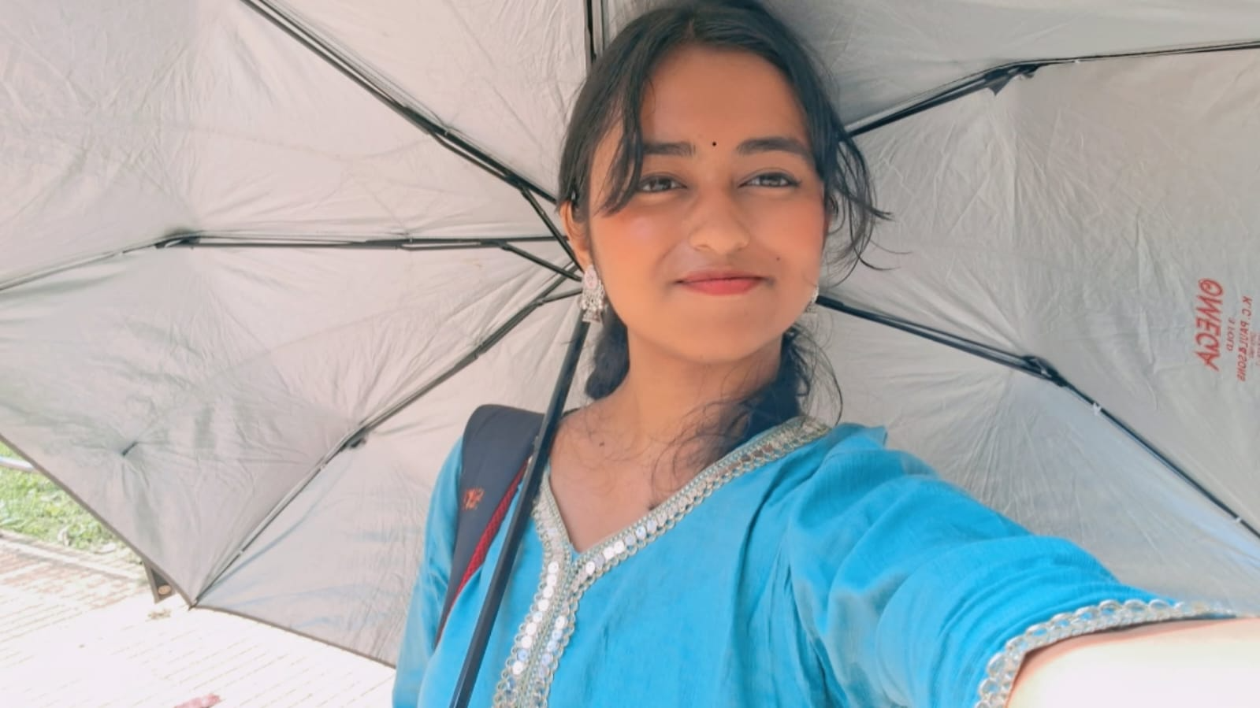
Soumyadipta Bhattacharyya

Position: Wing Representative for D block 1st Floor-NH Girls
Co-ordinator for Safety and Security Team
Introduction: 25MS student, you’ll mostly find me active so never hesitate to reach out and I’ll do my best to help!!
Contact Information: e-Mail- sb25ms288@gmail.com
Phone- +91 7439583395

